**Online Book Store**

* The Online Book Store System provides Microservices Architecture based software solution.
* This Online Book store had two stack holders
* Admin
* Customer
* Here Different Microservices are combined together to perform as a unified application.
* All the microservices are communicating with each using Feign Client.

**Architecture Diagram for Admin**

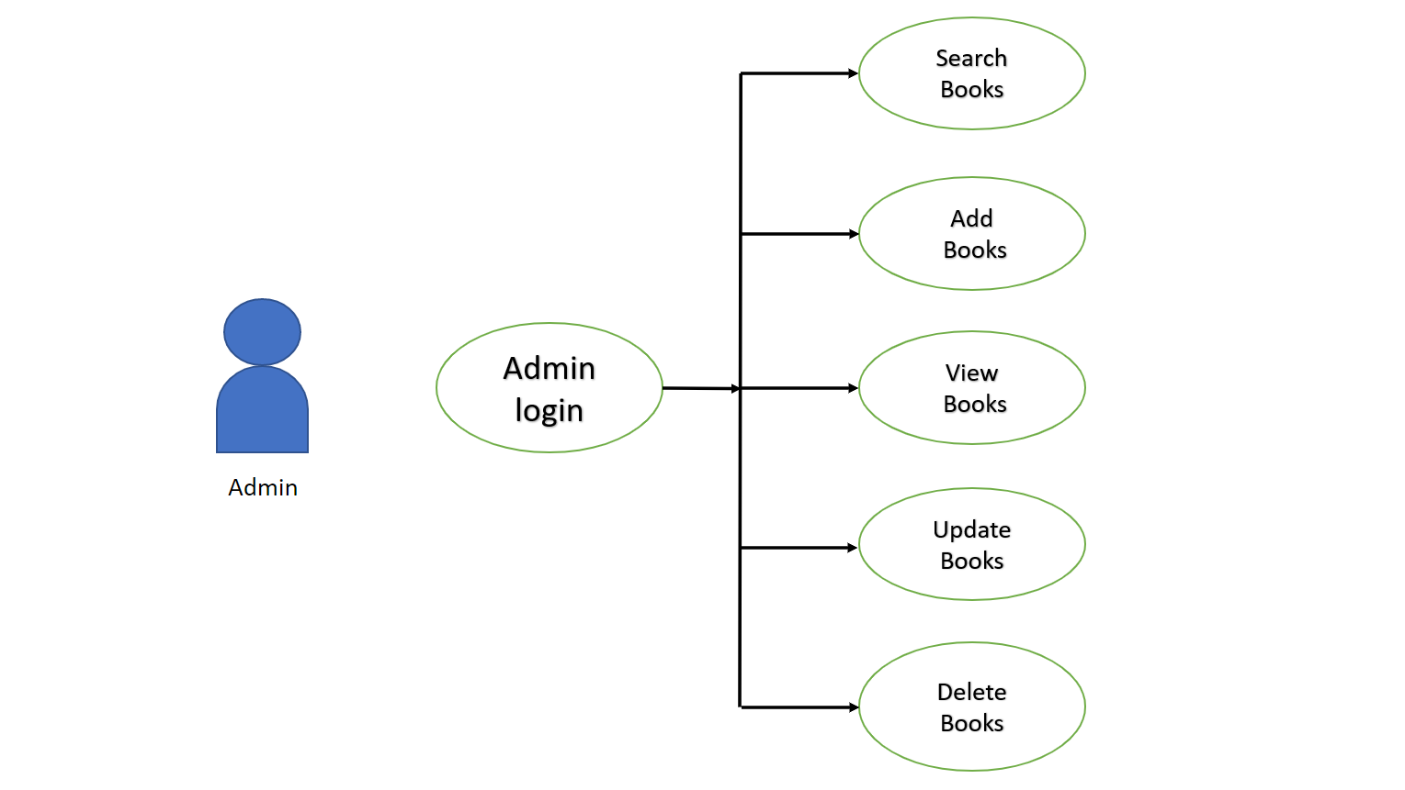

**Architecture Diagram for Customer**

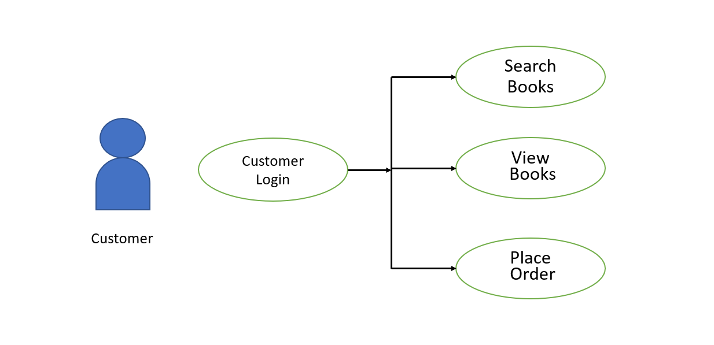

**Client-Server Architecture**

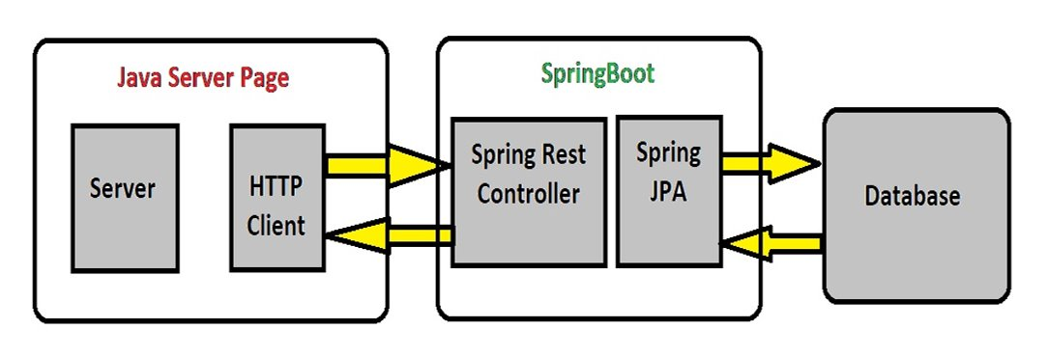

**Technologies Used**

* **Front End**: Java Server Page
* **Backend**: Java, **Spring Boot**, **Restful-Services**, **Hibernate,Spring-DataJpa, Ehcaching, EurekaServer , JWT, Slf4j.**
* **Database**: MySQL - database
* **Tools**: **Spring Tool Suite, Swagger, Postman**.

**Working Microservices**

* Authorization microservice
* Inventory Microservice
* Order Microservice
* Netflix Eureka Server

Authorization Microservices

* Authentication Microservices will perform operations like:
* Login
* Logout
* Authentication will provide the JWT token after user’s validation.
* Providing the authorization based on user’s login.
* The microservice is running in port 8008 with servlet path “/authorization”.

Inventory Microservices

* Inventory Microservices will perform operations like:
* View Books
* Add Book
* Update Books
* Delete Books
* Search Book
* This microservices interacts with the database to store and manipulate the data.
* Here EhCaching is used at service layer.
* The microservice will run on port 8082 with servlet path “/inv-ms”.

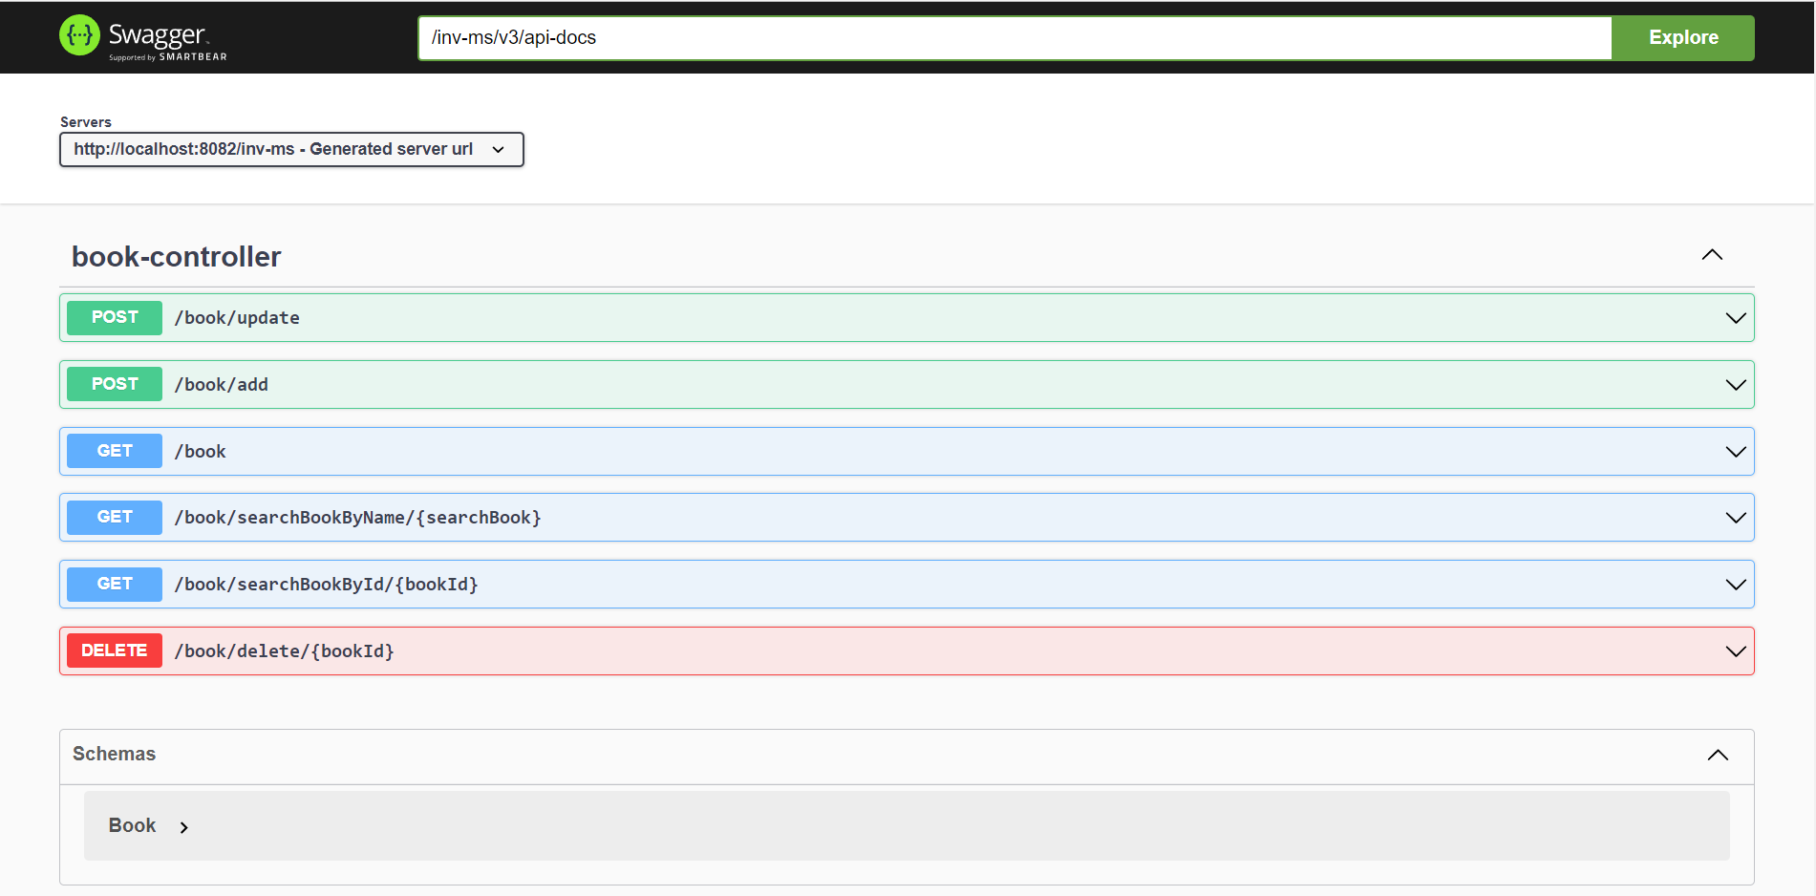

Order Microservices

* Order Microservices will perform operations like:
* View Orders
* Place Orders
* This microservice will run on port 8083 with servlet path “/ord-ms”.
* It interacts with Inventory Microservices for Placing Book Order using Feign Client.

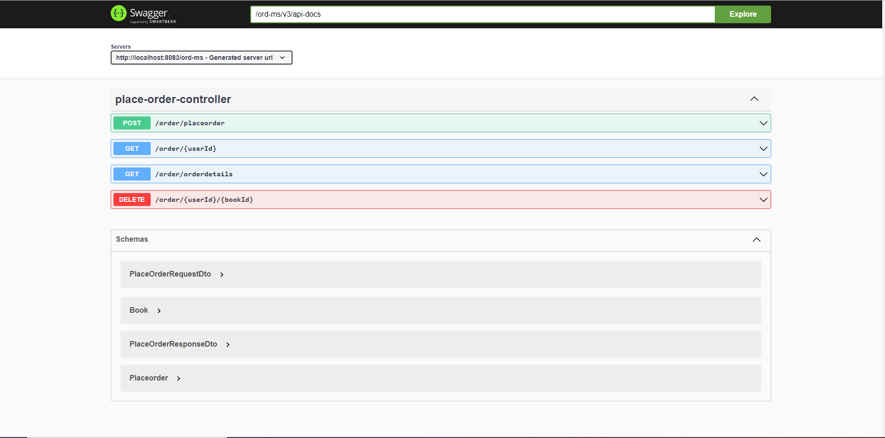

Netflix Eureka Server

This Microservice acts as a service which registers all the microservices running on different ports.

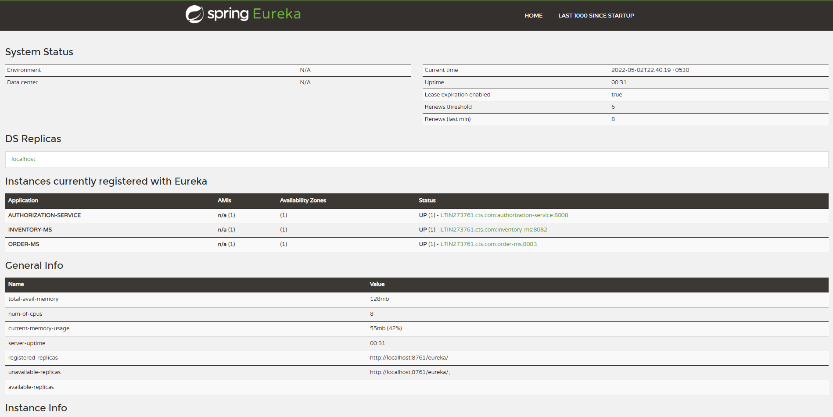

**Client Book Portal**

* The Book Portal acts as a client interface through which the user or admin can perform all operations.
* This Client interacts with Inventory, Order & Authorization Microservice are interacting with each other using Feign Client.
* This Client will run on port 8084

**User Interface of Online BookStore Application**

1.Login(http://localhost:8084/login)

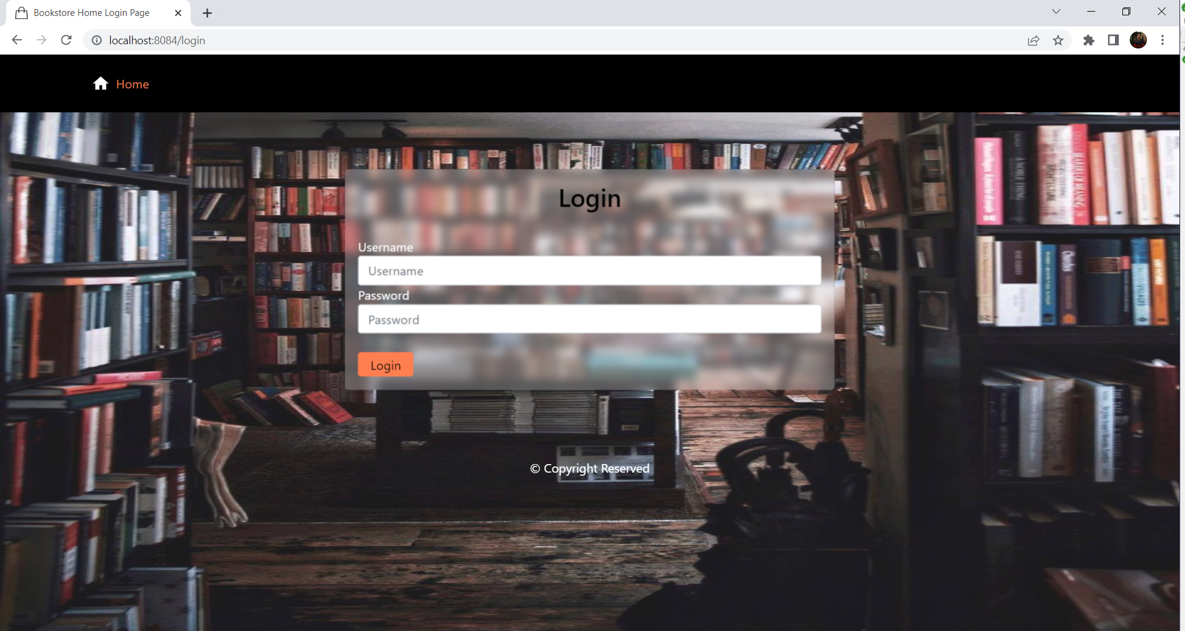The user's name and password are input which is validating against the credentials present in the mysql database.

2. Admin Dashboard

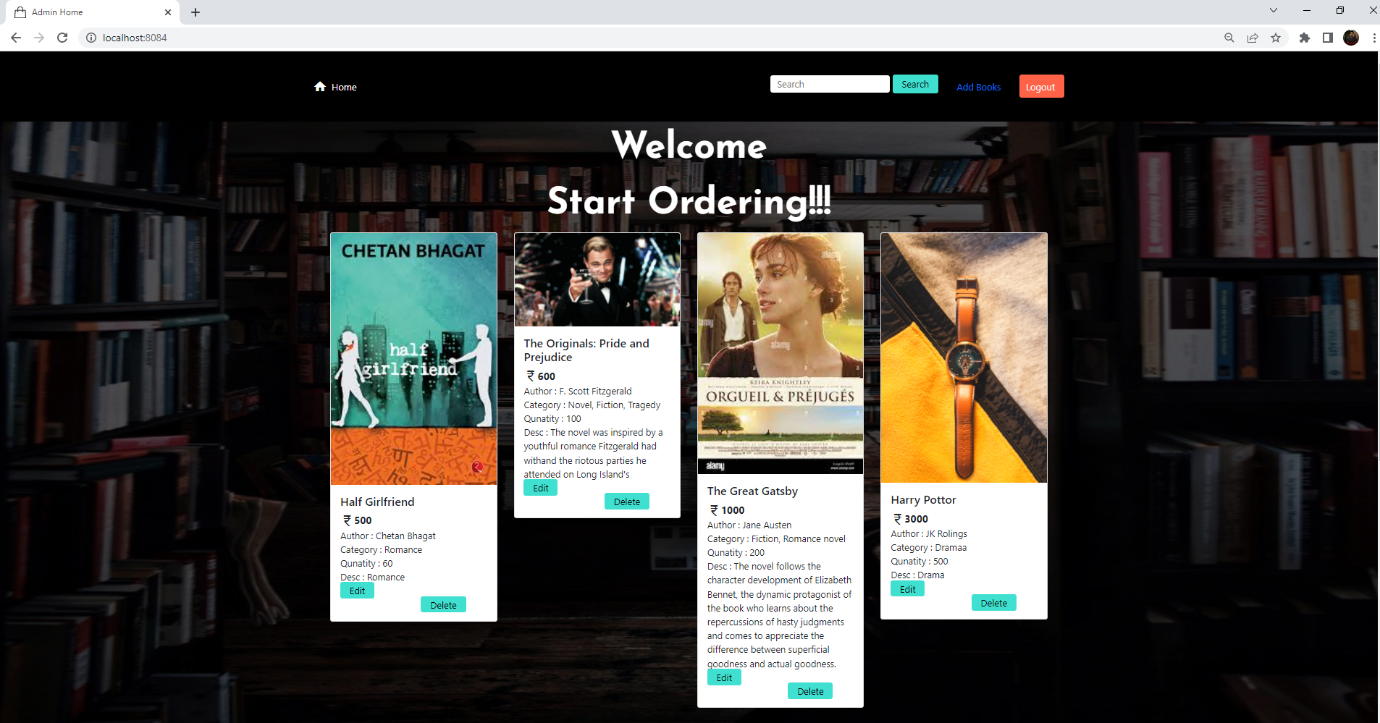

3.Customer Dashboard

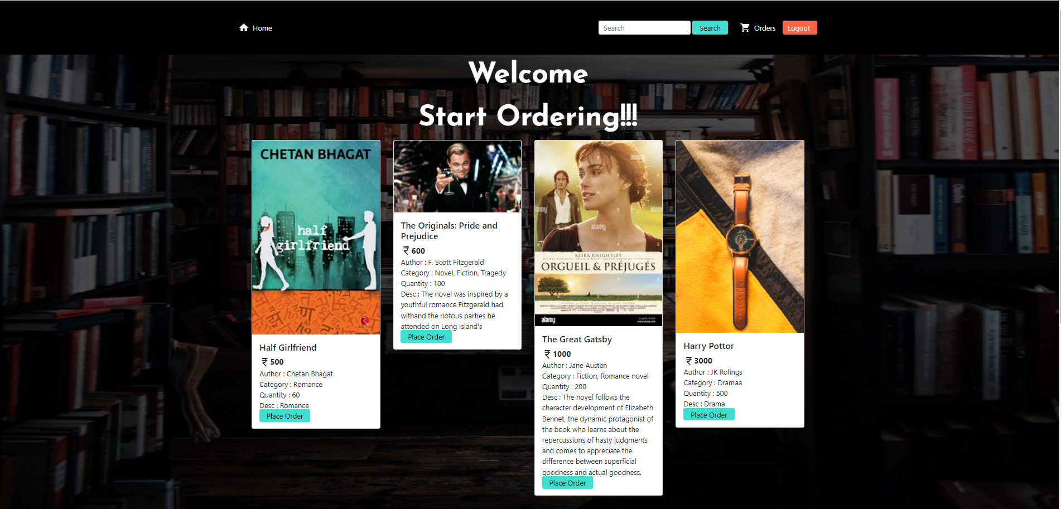

-------------------------------------End-----------------------------------